ECEN 325

Lab 1: First Order Circuits

Section 506

1/28/2020

Jason Gilman

TA: Mandela

**Introduction:**

In this lab, we constructed two first order circuits. One resembled a low-pass filter, while the other took the form of a high-pass filter. We then produced and analyzed the bode and time-domain waveforms to collect information on the circuits.

**Calculations:**

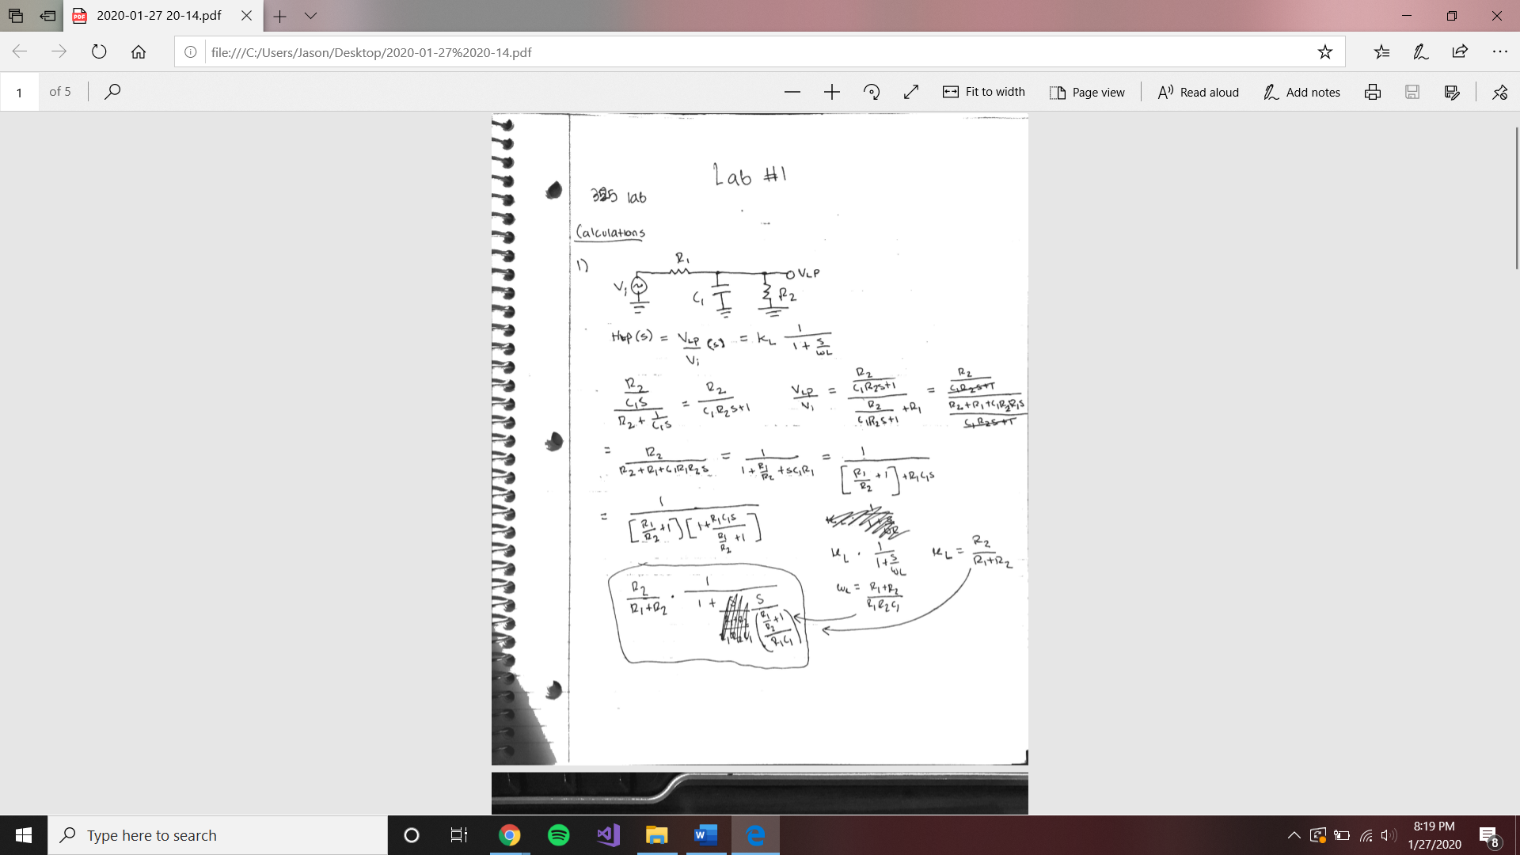

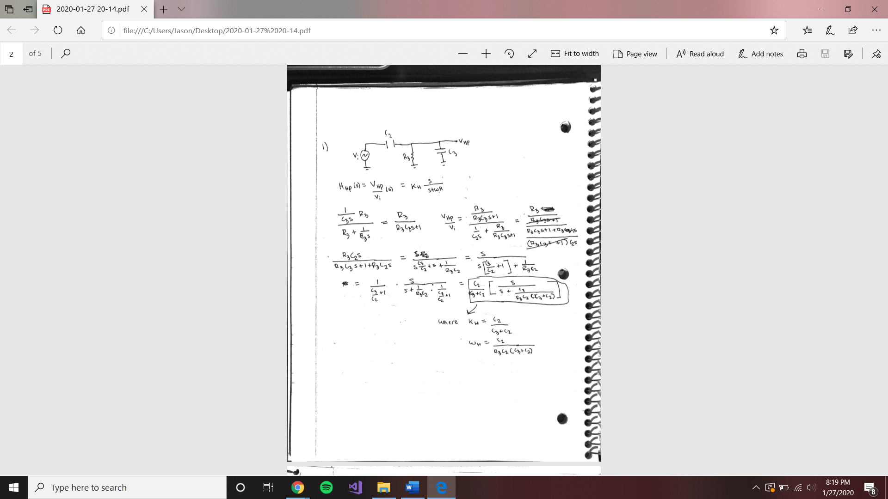

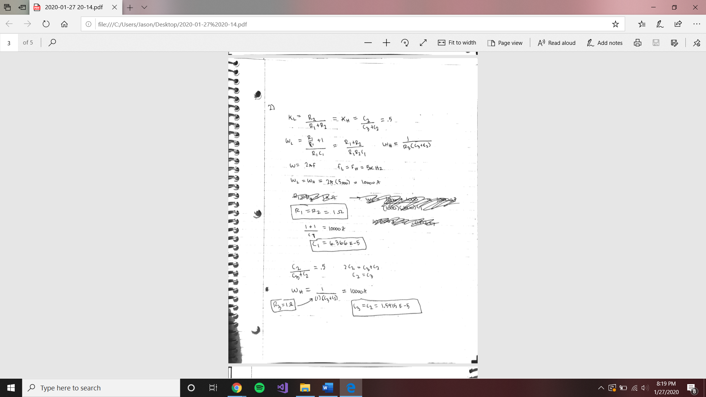

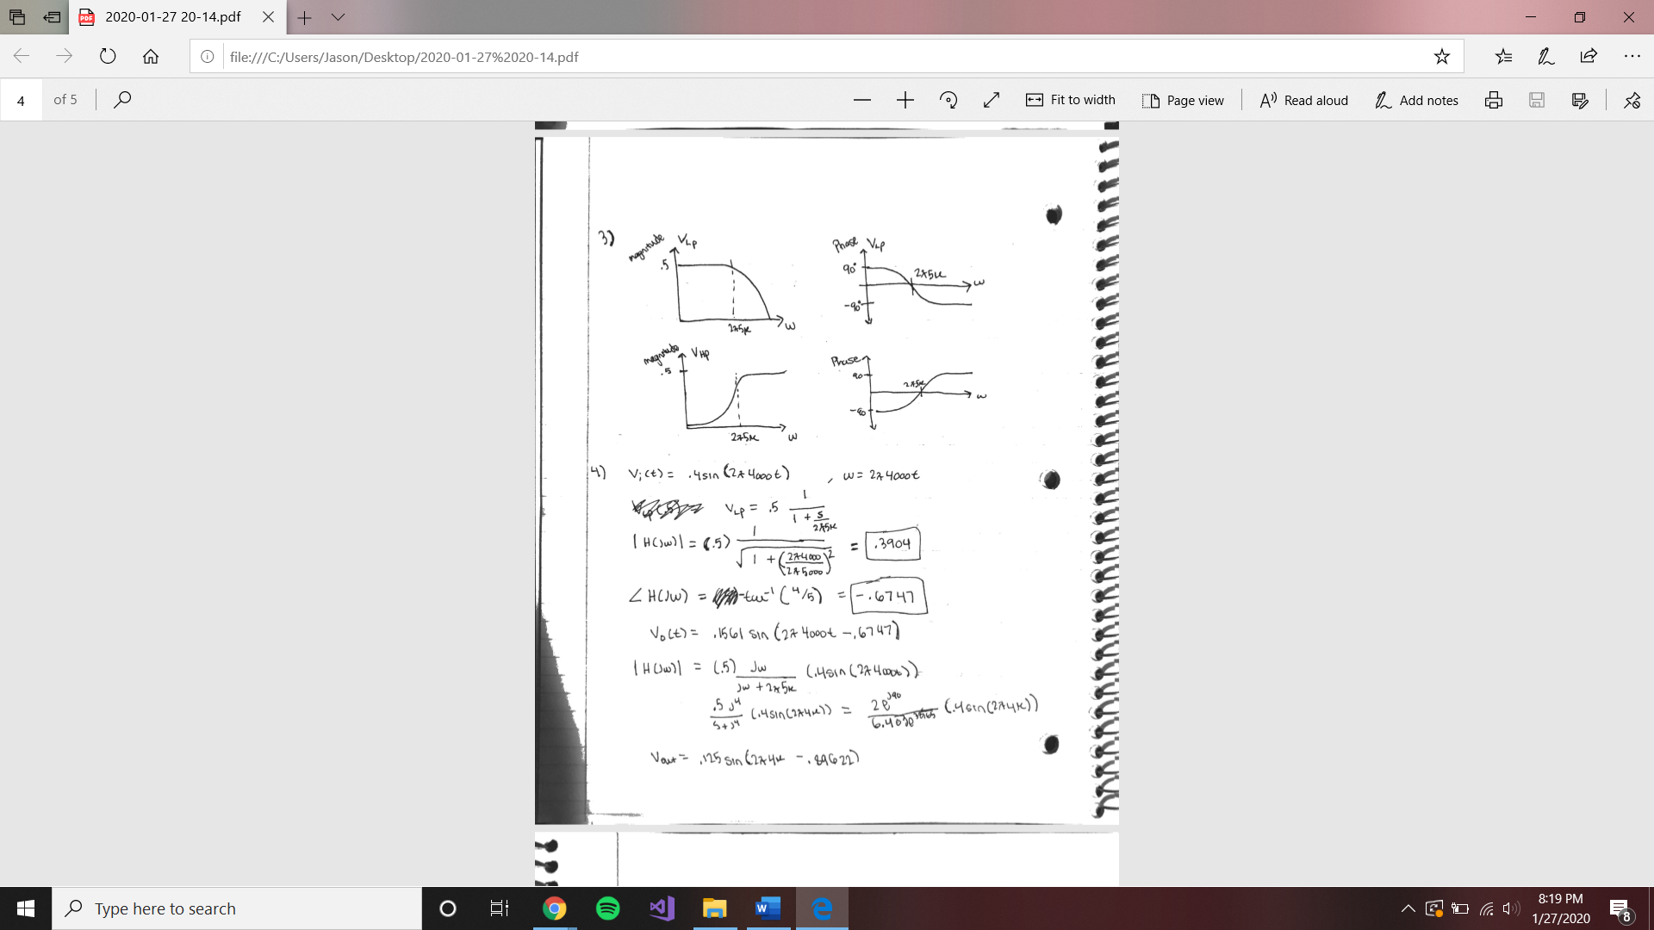

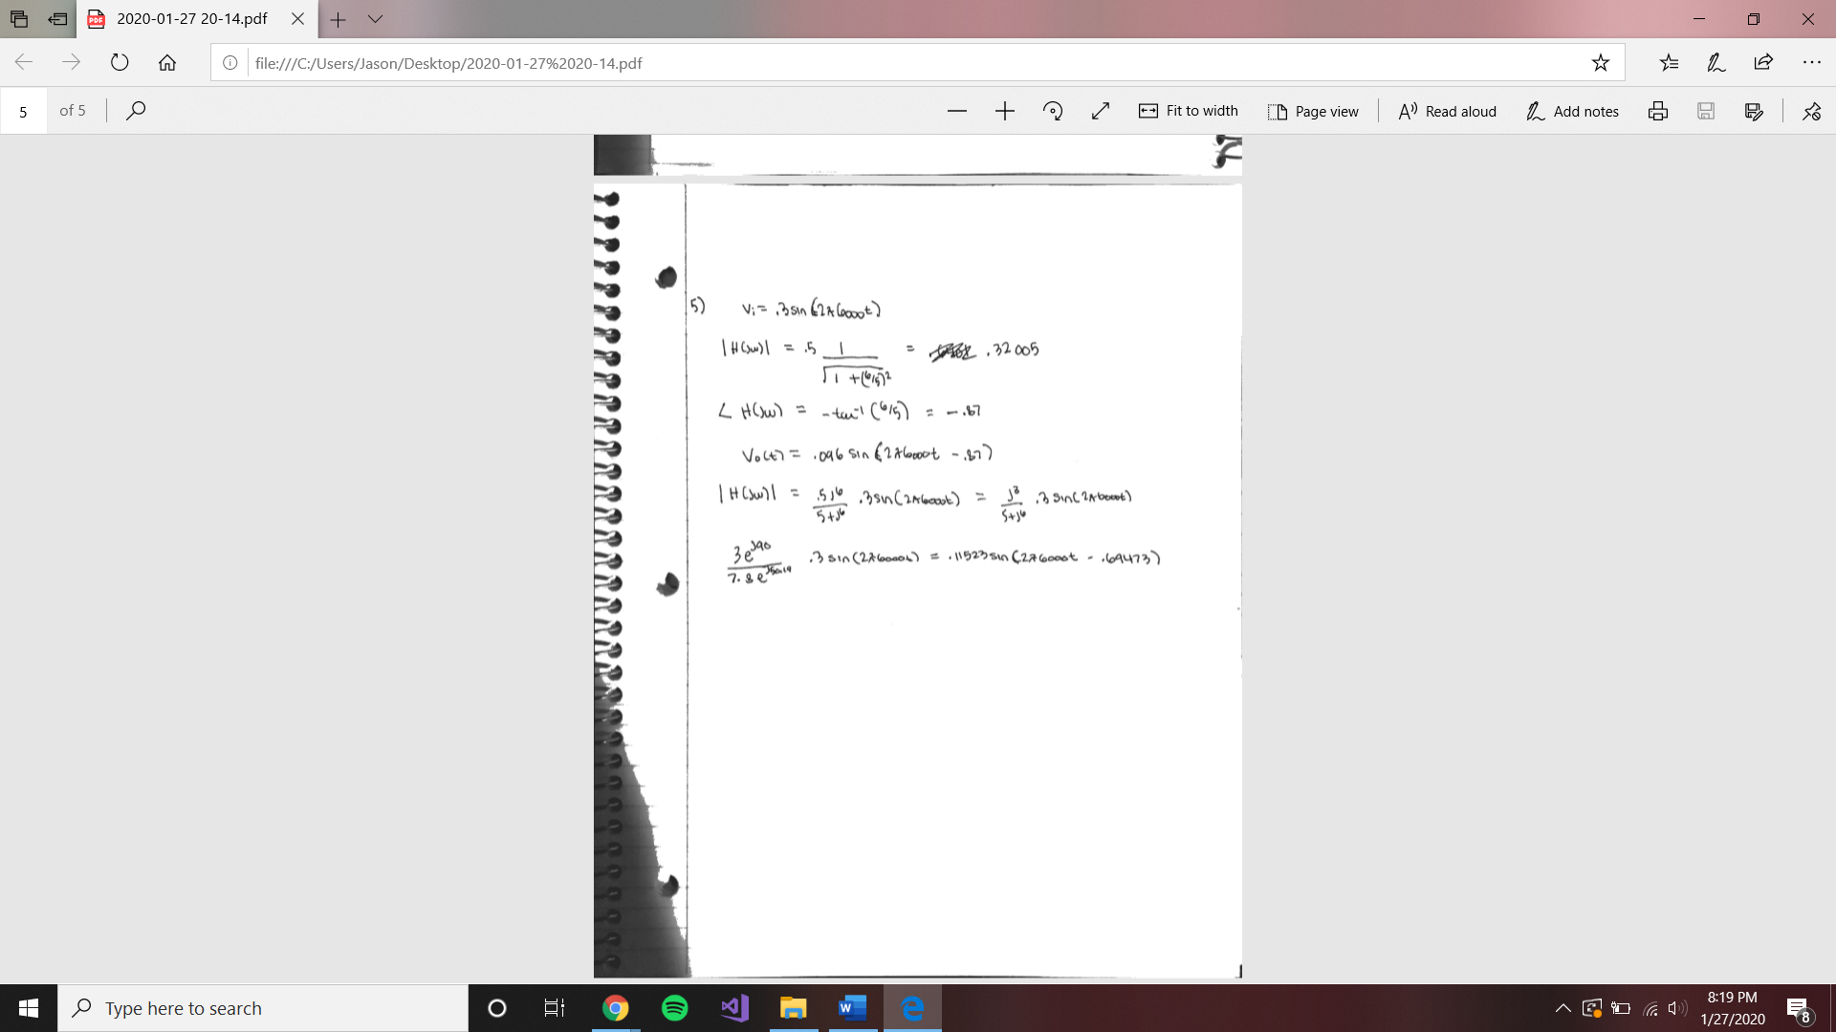

**Schematics:**

Low-pass circuit

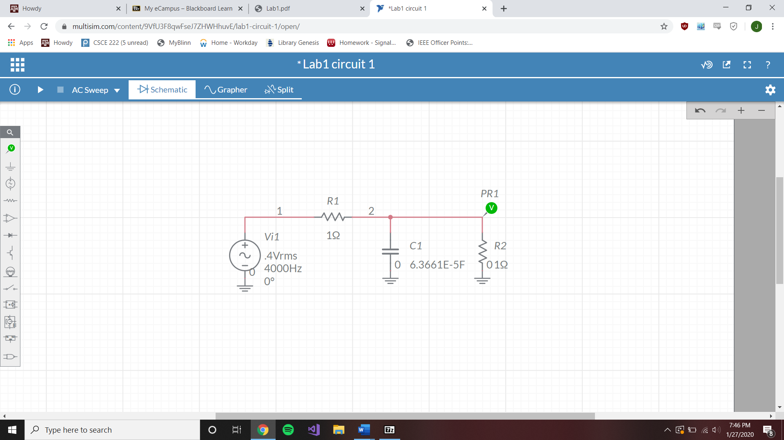

High-pass circuit

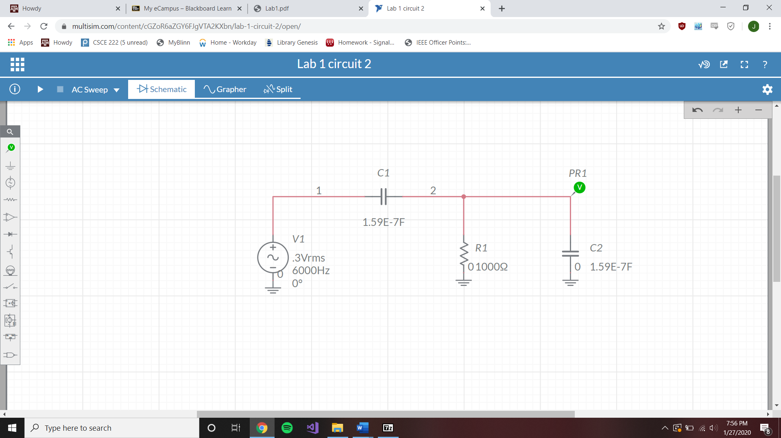

**Simulations:**

Low-pass Bode plot

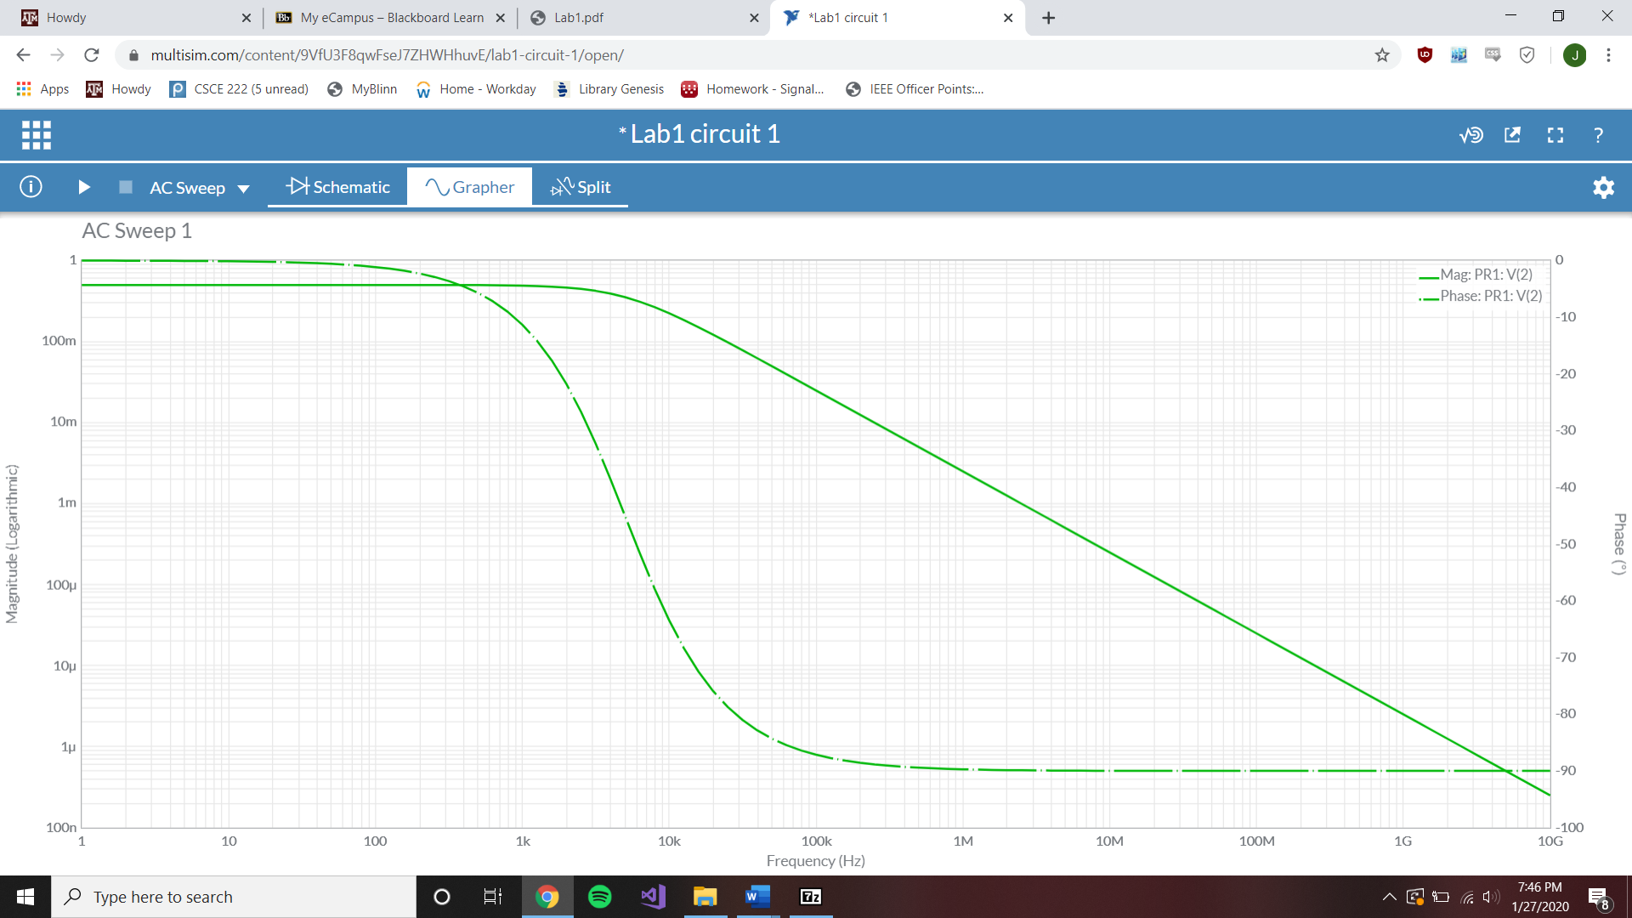

Low-pass F=4k Hz Time-Domain plot

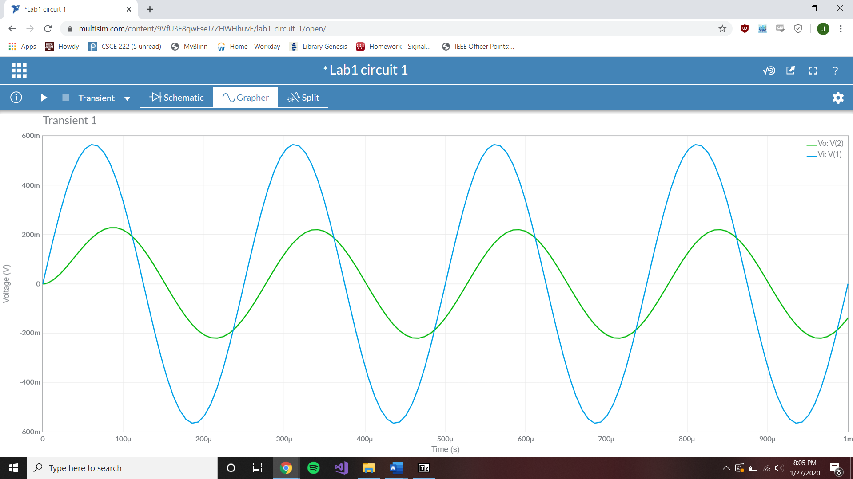

Low-pass F=6k Hz Time-Domain plot

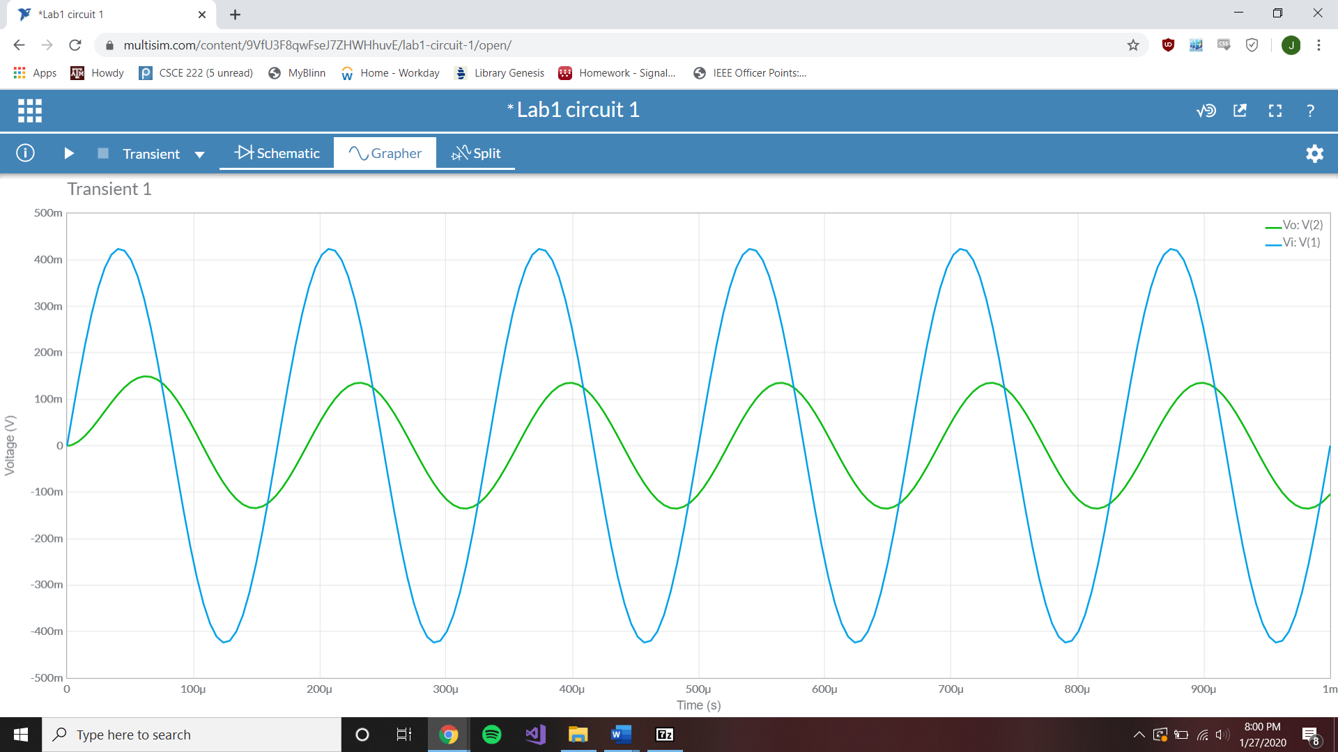

High-pass Bode plot

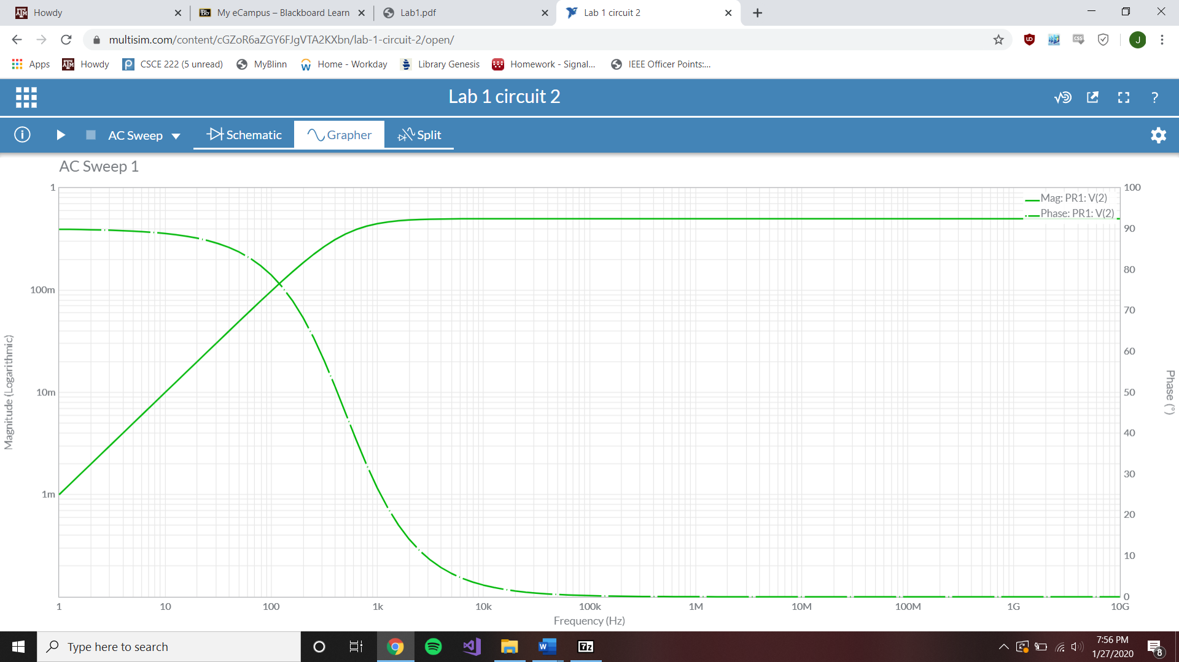

High-pass F=4k Hz Time-Domain plot

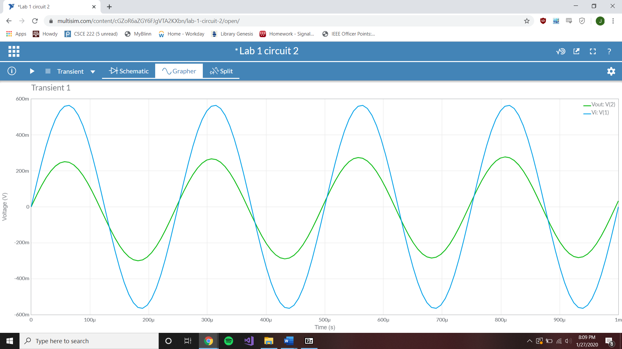

High-pass F=6k Hz Time-Domain plot

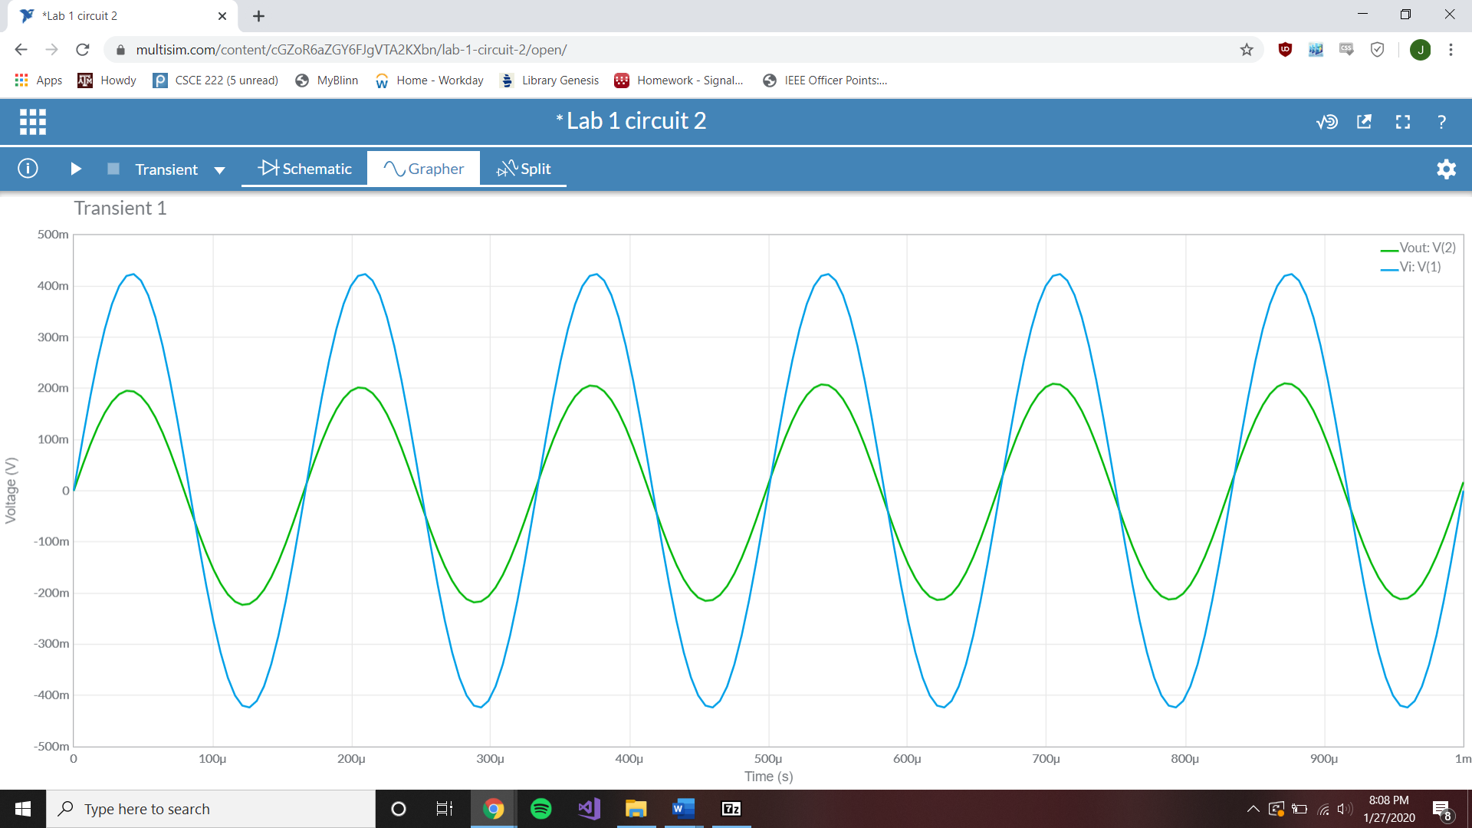

**Measurements:**

Low-pass Bode Measurement

Passband gain = -3.3245 dB 3 dB Freq = 5.0409 kHz

4k Hz magnitude = -5.4896 dB 6k Hz magnitude = -7.2016 dB

4k Hz phase = -38.56621° 6k Hz phase = -49.94037°

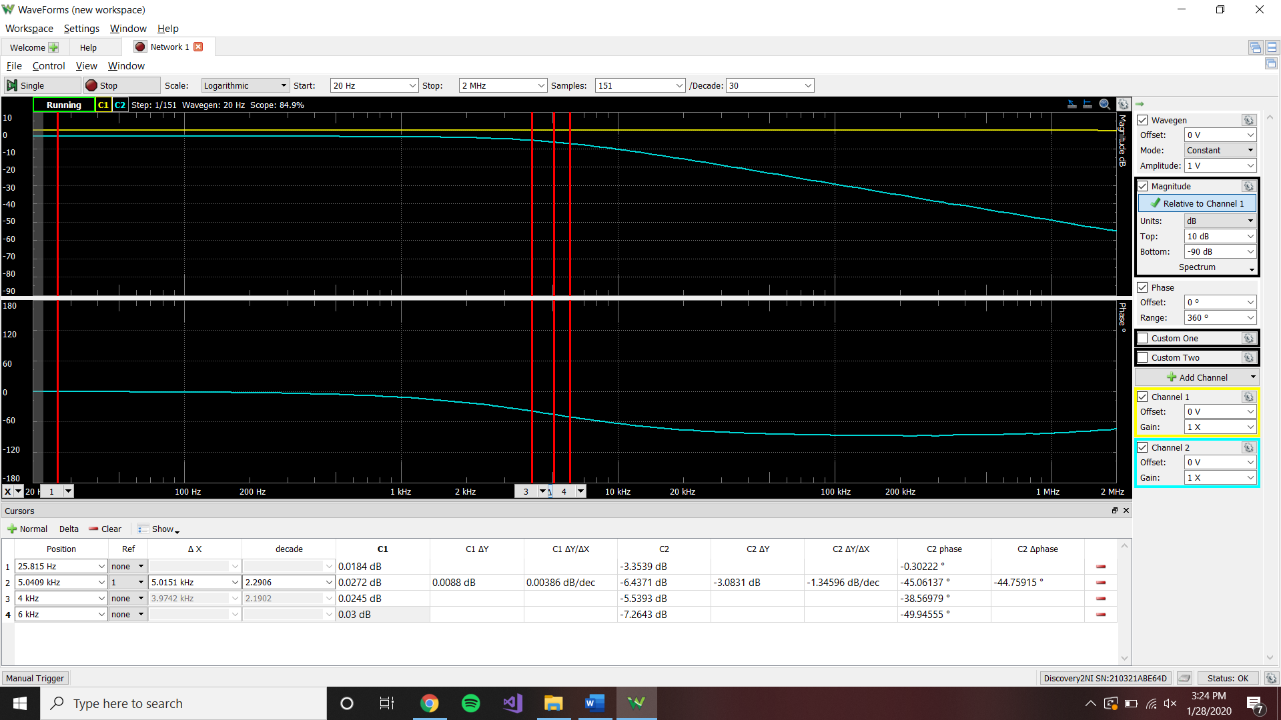

Low-pass Time-Domain Measurements

Vi(t) = .4sin(2pi4000t) Vi(t) = .3sin(2pi6000t)

Magnitude Vi = .40118 V Magnitude Vi = .30084 V

Magnitude Vo = .21165 V Magnitude Vo = .13024 V

Phase between = -28.8° Phase between = -43.2°

Vi(t) = .4sin(2pi4000t)

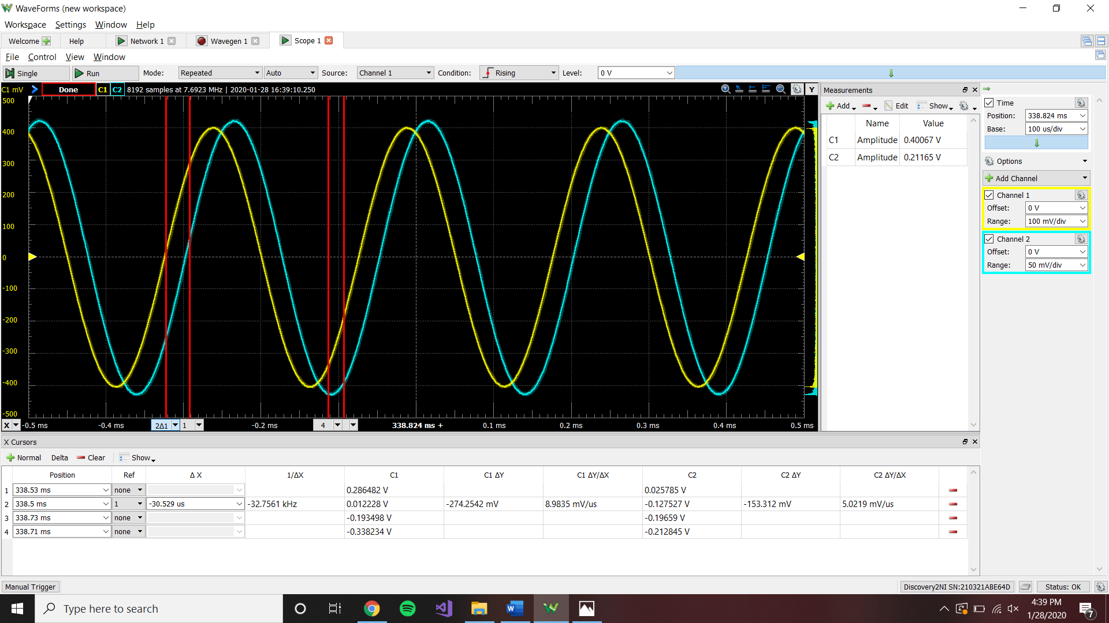

Vi(t) = .3sin(2pi6000t)

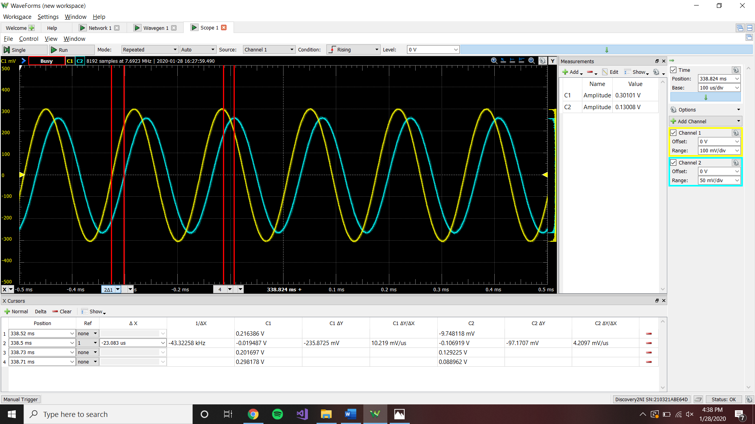

High-pass Bode Measurement

Passband gain = -15.0175 dB 3 dB Freq = 5.1039 kHz

4k Hz magnitude = -19.2584 dB 6k Hz magnitude = -17.4797 dB

4k Hz phase = 51.05° 6k Hz phase = 39.644°

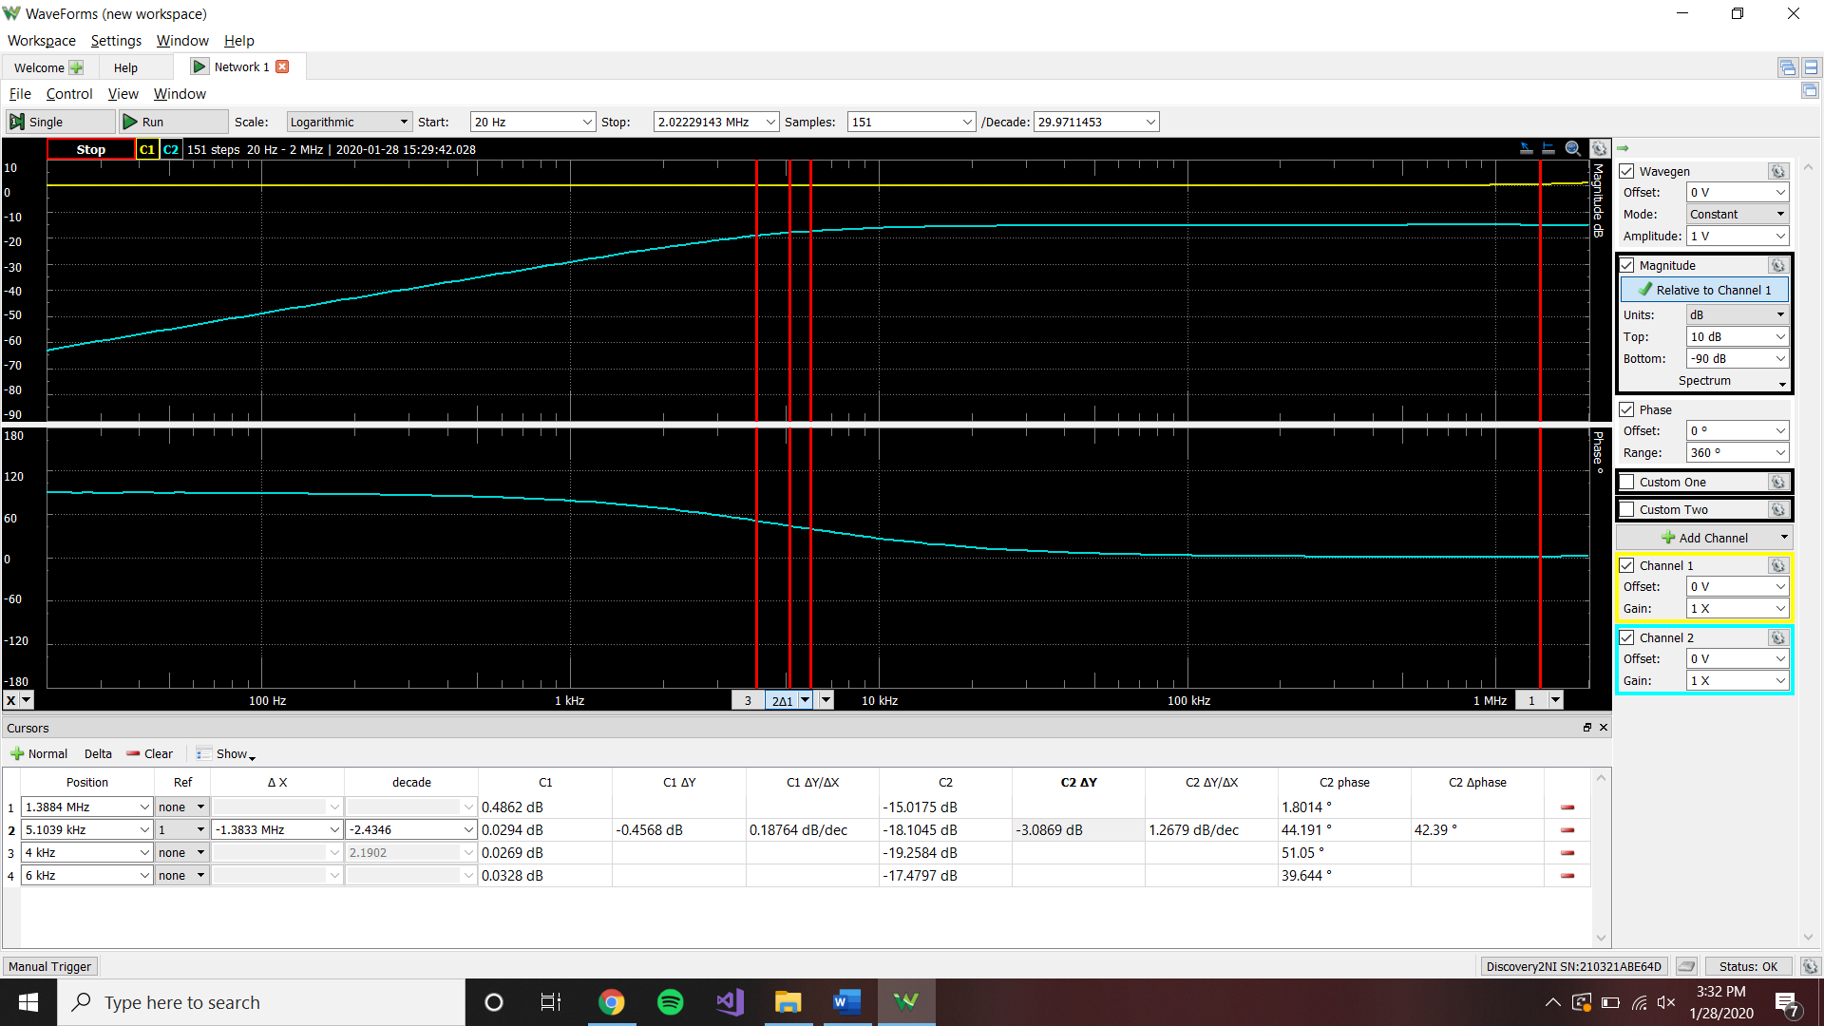

High-pass Time-Domain Measurements

Vi(t) = .4sin(2pi4000t) Vi(t) = .3sin(2pi6000t)

Magnitude Vi = .40050 V Magnitude Vi = .30084 V

Magnitude Vo = ..04341 V Magnitude Vo = .03985 V

Phase between = 57.6° Phase between = 43.2°

Vi(t) = .4sin(2pi4000t)

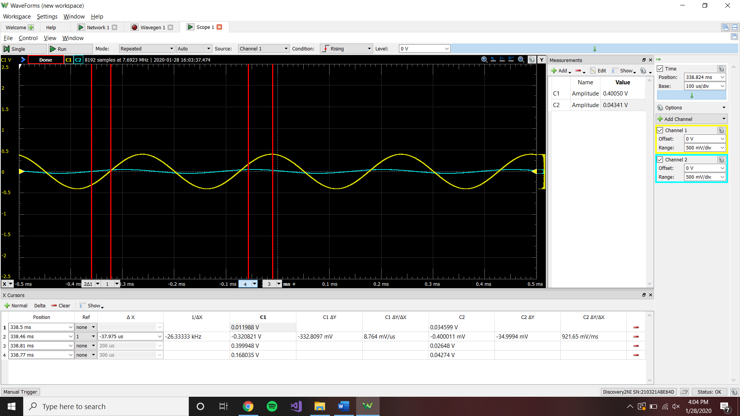

Vi(t) = .3sin(2pi6000t)

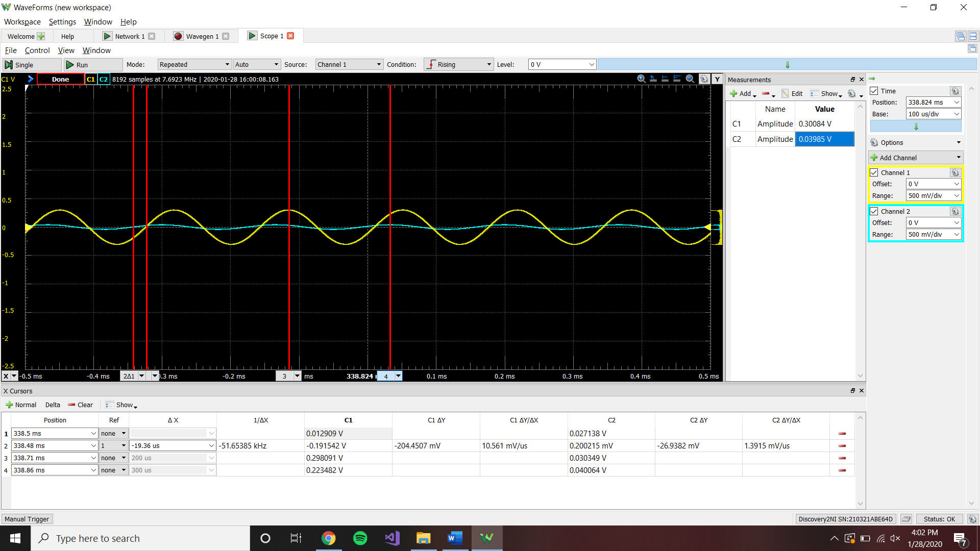

|  |  |  |
| --- | --- | --- |
|  | Vi(t)=.4sin(2pi4000t) | Vi(t)=.3sin(2pi6000t) |
| Magnitude, Calculated, Low-Pass | -8.16 dB | -9.89 dB |
| Magnitude, Simulated, Low-Pass | -9.88 dB | -11.32 dB |
| Magnitude, Measured, Low-Pass | -5.4896 dB | -7.2016 dB |
| Phase, Calculated, Low-Pass | -38.6598° | -50.1944° |
| Phase, Simulated, Low-Pass | -39.927° | -50.10° |
| Phase, Measured, Low-Pass | -38.56621° | -49.94037° |
| Magnitude, Calculated, High-Pass | -18.35 dB | -16.43 dB |
| Magnitude, Simulated, High-Pass | 53.91 | 53.94 dB |
| Magnitude, Measured, High-Pass | -19.2584 dB | -17.4797 dB |
| Phase, Calculated, High-Pass | 48.32° | 41.33° |
| Phase, Simulated, High-Pass | 7.07° | 4.80° |
| Phase, Measured, High-Pass | 51.05° | 39.644° |

**Conclusion:**

Looking at the table above, you can see that many of the results, dependant on the source, produced similar results. The phases seem to be more in unison through the calculated, simulated and measured results compared to the magnitudes. This could have been due to errors in calculations, or non-exact readings in the data. For example, when pulling data off the bode plot, instead of reading at exactly 4k Hz, the cursor could have been at 3.89k Hz. These small issues could explain the differences in data.